

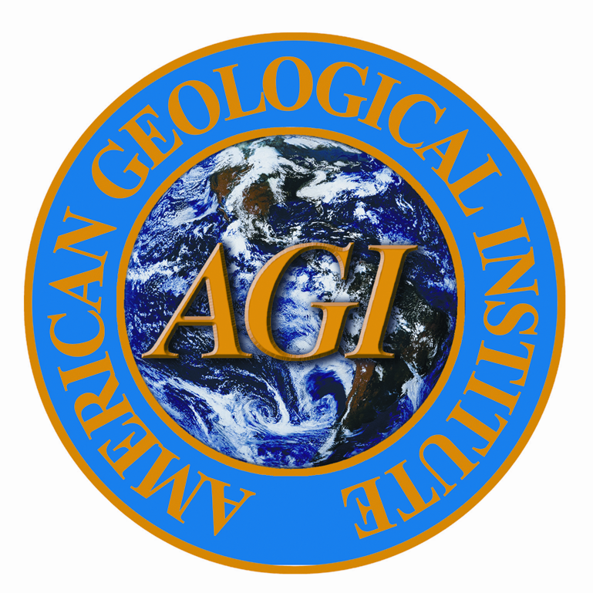

Tonia Teacher

Has successfully completed the
Summer Institute of the Earth Science by Design Program
for 80 hours of professional development.

June-July, 2004

_________________________
Larry Leader,
Site Leader

